**Experiment - 1.4(d)**

**Student Name: Milan Sharma UID: 23MAI10003**

**Branch: ME – CSE - AIML Section/Group: MAI – 1 (A)**

**Semester: 1st Date of Performance: 29 Aug 2023**

**Subject Name: Python Programming Subject Code: 23 CSH 623**

1. **Aim of the Experiment :**

Write a python program to generate Fibonacci series.

1. **Objective of the Experiment :**

To generate Fibonacci series.

1. **Algorithm/ Steps for Experiment**

1.        Declare variables i, a,b , show

2.        Initialize the variables, a=0, b=1, and show =0

3.        Enter the number of terms of Fibonacci series to beprinted

4.        Print First two terms of series

5.        Use loop for the following steps-> show=a+b-> a=b-> b=show-> increase value of i each time by 1-> print the value of show

6.        End

1. **Code for Experiment :**

nterms = int(input("How many terms? "))

n1, n2 = 0, 1

count = 0

if nterms <= 0:

print("Please enter a positive integer")

elif nterms == 1:

print("Fibonacci sequence upto",nterms,":")

print(n1)

else:

print("Fibonacci sequence:")

while count < nterms:

print(n1)

nth = n1 + n2

n1 = n2

n2 = nth

count += 1

1. **Result/Output :**

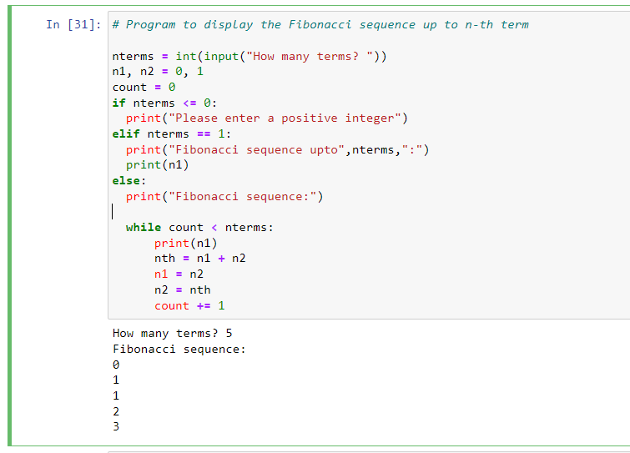

**Learning outcomes (What I have learnt):**

1. Learnt what is Fibonacci series.

**Evaluation Grid (To be created as per the SOP and Assessment guidelines by the faculty):**

|  |  |  |  |
| --- | --- | --- | --- |
| **Sr. No.** | **Parameters** | **Maximum Marks** | **Marks Obtained** |
| **1.** | **Student Performance**  **(Conduct of experiment)**  **Objectives/Outcomes.** | 12 |  |
| **2.** | **Viva Voce** | 10 |  |
| **3.** | **Submission of Work Sheet**  **(Record)** | 8 |  |